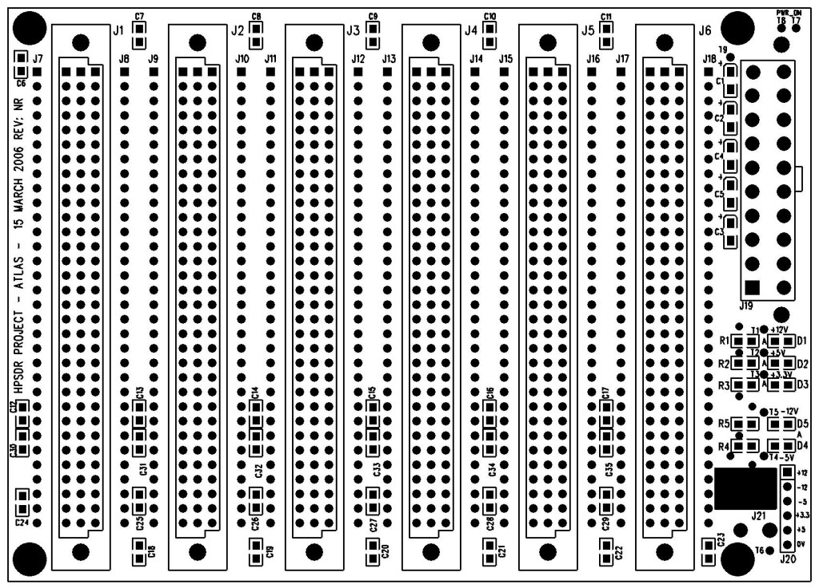

BOARD: 4 LAYER , 5.500" X 3.940", J1-J6 slots spaced at 0.800"

STACKUP:
- GROUND PLANE (TOP LAYER)
- YBUS
- POWER PLANES
- XBUS (BOTTOM LAYER)

POWER:
- +12VDC, -12VDC, +5VDC, -5VDC, +3.3VDC

STANDARD CONNECTORS:
- 96 pin DIN41612 (J1-J6) - BUS
- 20 pin ATX PS (J15) - POWER
- PS LOAD (J21) - LOAD
- 6 pin 0.100 SIP (J20) - POWER
- T1-T6 for external LEDs
- T7-T8 for remote ATX power on switch.
- T9 for ATX_PWR_OK.

OPTIONAL CONNECTORS:
- 64 pin DIN41612 (using XBUS only)
- 32x2 0.100 HEADER (using XBUS only)

MISC FEATURES:
- Each pin of the slot connectors can be isolated from the bus and then jumpered to another bus pin or signal. J7-J18 are provided for optional 32 pin SIP headers or wire-wrap pins. This allows re-routing the bus as needed.
- The user can decide to use the XBUS only by populating J1-J6 with DIN41612 64 pin "Type B" connectors or 32 pin dual 0.100 headers.
- J21 allows for an optional load resistor to be placed on the +5V bus when using an ATX power supply. The load resistor should be mounted to a proper heatsink.
- D1-D5 are SMT LEDs connected to the power bus (+12, -12, +5, -5, +3.3) through dropping resistors R1-R5.
- T1-T6 allow panel mounting of LEDs instead of SMT.
- All supplies bypassed.

NOTES:
- The buses are separated into the XBUS and YBUS, with 24 lines each.
- The XBUS is routed on the bottom layer of the PCB.
- The YBUS is routed between the top ground plane layer and the power plane layer.
- The XBUS is divided into the subgroups XA0-XA7, XB0-XB7, XC0-XC7, XDC.
- The YBUS is divided into the subgroups YA0-YA7, YB0-YB7, YC0-YC7, YDC.
- XDC and YDC are daisy chained between slots (see schematic).
- The XBUS and YBUS subgroup divisions are for physical naming purposes only.
- Since the YBUS is sandwiched in between two plane layers, it should be used to route medium speed signals or clocks between boards. While not intended to be a LVDS bus, it should be adequate for clock speeds up to 20-25 MHz.
- J7, J9, J11, J13, J15, J17 are connected to the XBUS. J8, J10, J12, J14, J16, J18 are connected to the YBUS. On the bottom side of the Atlas board, J7-J18 are then connected by traces to J1-J6. This allows you to isolate pins on the J1-J6 connectors by cutting the connecting trace. See 9 below.
- If an application requires re-routing signals on the bus, a possible solution is to populate the related pin on connectors J7-J18 with wire wrap pins. The signal then can be routed on top of the Atlas board with wire wrap wire. Since the top of the board is a ground plane, the wire wrap wire should lay directly on the board surface to minimize crosstalk/noise.
- An alternative to wire wrap is to place jumper wires between the rerouted bus signals on the J7-J18 pads.
- See physical bus pinout below.

DIN41612 96 PIN

PIN NAME
A1 +12VDC
A2 X0A0
A3 X1A1
A4 X2A2
A5 X3A3
A6 X4A4
A7 X5A5
A8 X6A6
A9 X7A7
A10 X8B0
A11 X9B1
A12 X10B2
A13 X11B3
A14 X12B4
A15 X13B5
A16 X14B6
A17 X15B7
A18 X16C0
A19 X17C1
A20 X18C2
A21 X19C3
A22 X20C4
A23 X21C5
A24 X22C6
A25 X23C7
A26 -12VDC
A27 X24DC
A28 -5VDC
A29 X25DC
A30 +3.3VDC
A31 X26DC
A32 +5VDC

PIN NAME
B1 +12VDC
B2 GND
B3 GND
B4 GND
B5 GND
B6 GND
B7 GND
B8 GND
B9 GND
B10 GND
B11 GND
B12 GND
B13 GND
B14 GND
B15 GND
B16 GND
B17 GND
B18 GND
B19 GND
B20 GND
B21 GND
B22 GND
B23 GND
B24 GND
B25 GND
B26 -12VDC
B27 GND
B28 -5VDC
B29 GND
B30 +3.3VDC
B31 GND
B32 +5VDC

PIN NAME
C1 +12VDC
C2 Y0A0
C3 Y1A1
C4 Y2A2
C5 Y3A3
C6 Y4A4
C7 Y5A5
C8 Y6A6
C9 Y7A7
C10 Y8B0
C11 Y9B1
C12 Y10B2
C13 Y11B3
C14 Y12B4
C15 Y13B5
C16 Y14B6
C17 Y15B7
C18 Y16C0
C19 Y17C1
C20 Y18C2
C21 Y19C3
C22 Y20C4
C23 Y21C5
C24 Y22C6
C25 Y23C7
C26 -12VDC
C27 Y24DC
C28 -5VDC
C29 Y25DC
C30 +3.3VDC
C31 Y26DC
C32 +5VDC

